MECA 482 Final Project – Furuta Pendulum

**Table of Contents**

**Overview**

**Operational Viewpoint**

**Logical/Functional Viewpoint**

**Capabilities Database**

**Mathematical Model**

**Software Model**

**Simulation**

**References**

**Appendix**

1. **Overview**

The Furuta Pendulum is a rotational inverted pendulum. It consists of a driven arm that rotates around on its axis. Attached to the arm is another motor that rotates around the vertical plane. Figure 1 below shows a basic overview of a Furuta Pendulum. The goal of the project is to balance the pendulum bar upright by actuating a motor at the base as shown in figure 1.

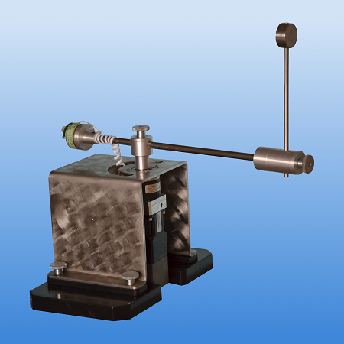

**Image 1.** Furuta Pendulum Model

The overall goal for the project is to control the lever arm in an upright positon and keep the arm in an upright position. If a disturbance is detected or a force is detected, The lever arm should respond to the disturbance and return back to its original stable upright position. A mathematical model as well as a software module will be implemented to represent the pendulum.

The deliverables of the project include:

* A mathematical model of the system
* The control system should be provided in Simulink
* The system will have a simulation with the control system and mathematical model
* A written final report
* A GitHub page with code, script, and reports and references listed

1. **Operational Viewpoint**

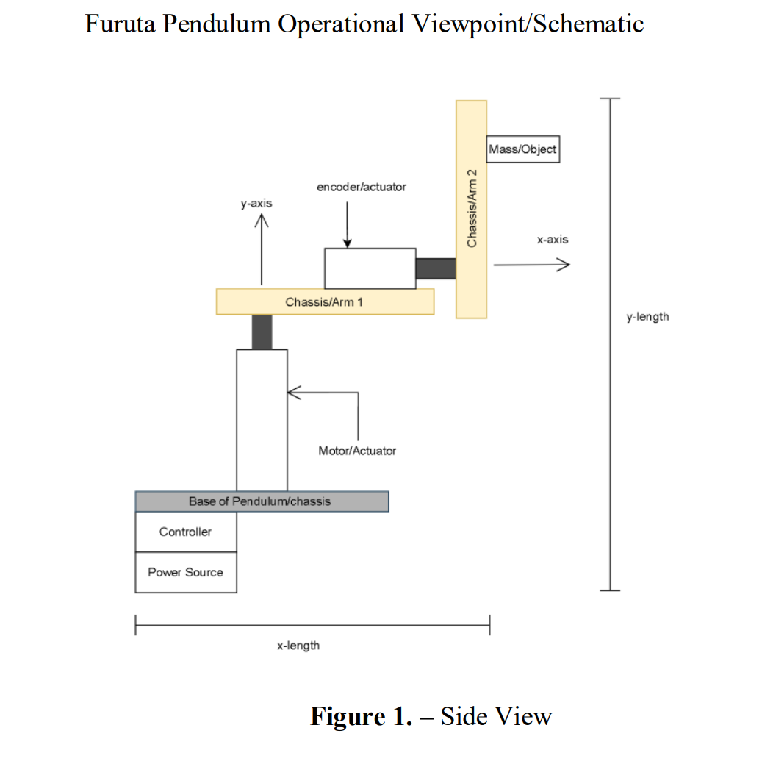

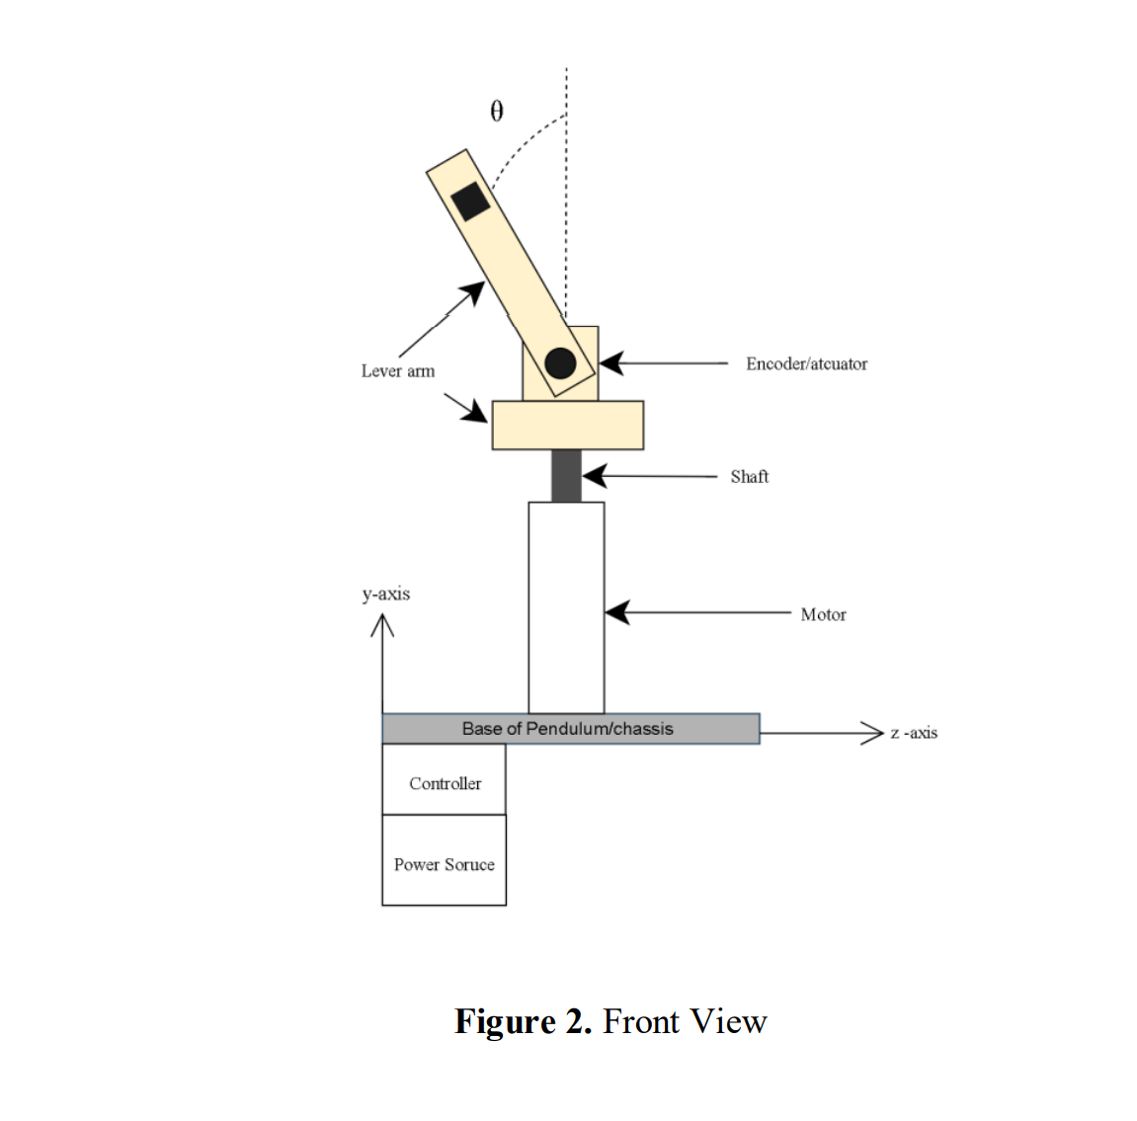

1. **Logical/Functional Viewpoint**

The logical/functional viewpoint of the future pendulum is based off of the operational diagram. For the logical/functional viewpoint, there are two degrees of freedom that the pendulum experiences.

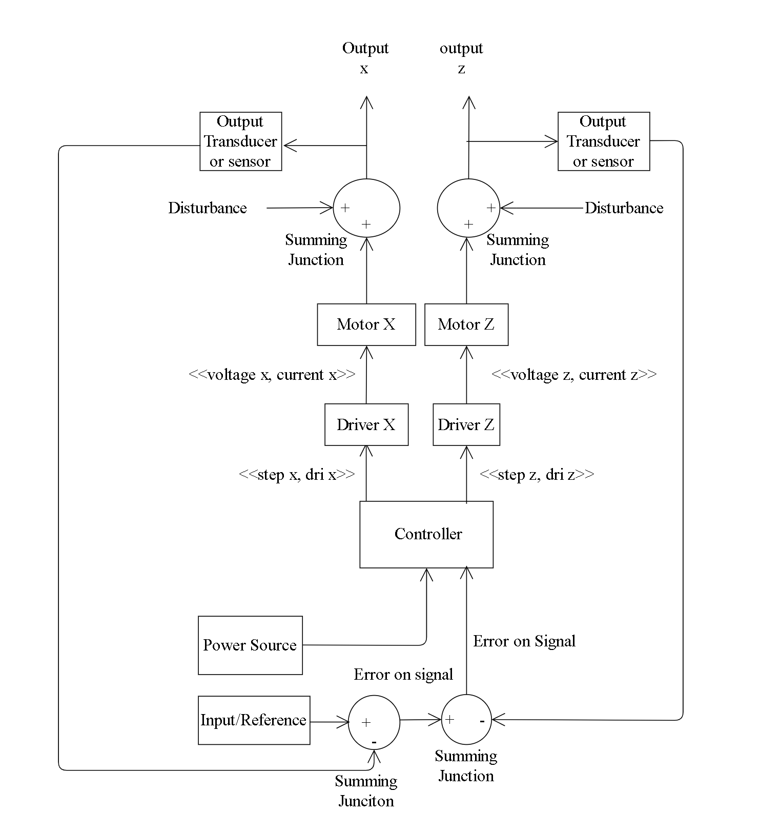

1. **Capabilities Database**

For the capabilities database, the system requirements were to stabilize the pendulum arm in an upright, original, stable position. This was done through functional, physical, and programmable requirements. The repeatability of requirements for the system was important as well since the pendulum are was expected to stabilize and move back to its original upright position after a disturbance was detected and be expected to do this over and over again.

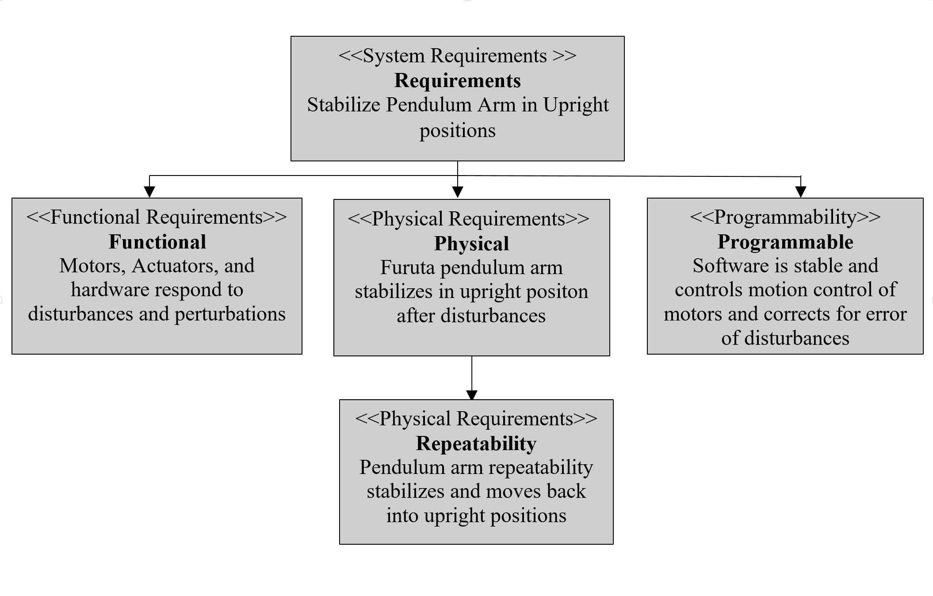

Capabilities Database

1. **Control of a Futura pendulum**

To control a pendulum, the center of mass of the lever arms must be taken into consideration as well as the length of the arms and the location of the pendulum arms in relationship to the desired final position of the Futura pendulum. When a disturbance is detected. The kinetic energy of the arm and the pendulum must also be considered when a disturbance is detected and when the pendulum tries to balance in its original stable position. Figure 15.2, below, from Springer, *“Automatic Control with Experiments”*, shows the geometric relationships in the Furuta pendulum. It is also important to consider the fact that constant gravity affects the second link (pendulum) but not the first link (arm).

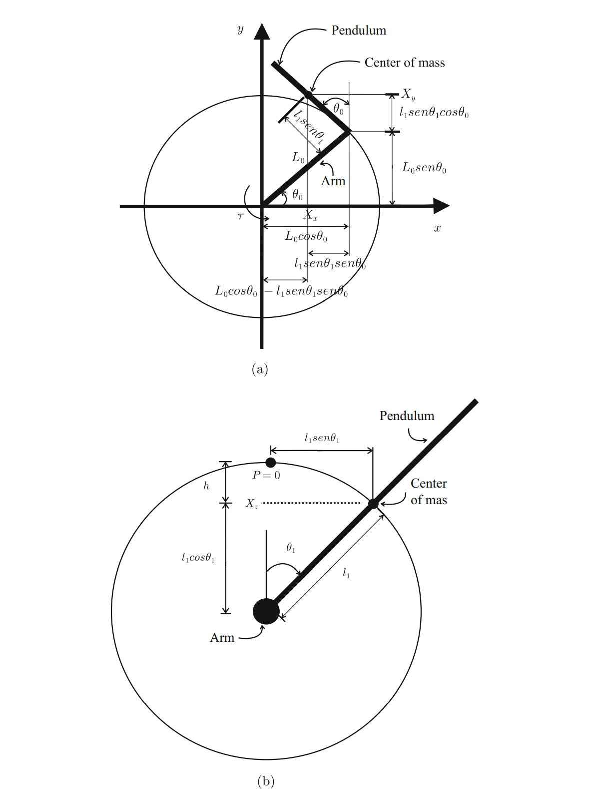

Figure 15.2 Geometric relationships in the Furuta Pendulum. View A, View

1. **Mathematical model**

For the mathematical model, the two lever arms must be taken into consideration (Lever arm 1 & Lever arm 2) since they interact with each other. The pendulum movement also dependent on both the combined movements of the arm and pendulum. The mathematical model must also consider the fact that gravity affects the pendulum arm but not level arm.

For the mathematical model, the kinematics of the lever arm must be taken into consideration, as well as the potential energy and kinetic energy of the lever arms too since there will be disturbances to the lever arms and the pendulum must respond to that error in order to return back to its original, stable state.

The Figure to the left shows a simplified diagram of the arm and the pendulum. Gravity affects the pendulum but not the arm. Equations of motion can be derived for both the pendulum and the arm as follows:

Base

arm

Pendulum

The equations of motion can be found as followed:

Considering Kinetic and potential energy:

Equation of motion for the pendulum arm

1. **Simulation**

Using MATLAB a simulation was able to be done to model the simulation on MATLAB. The figure below represents a basic model of the pendulum with a time variable added to show how long it will take for the pendulum to restore to its original positon after a disturbance was detected. A basic pendulum was created in MATLAB to model the motion of the pendulum. The figure below shows the pendulum in its original position before a disturbance was detected.



Simulation Diagram of Futura Pendulum Modeled in MATLAB

1. **Solid works**
2. **Conclusion**